Adapters and couplings
for high-pressure applications

Klingenberg, June 2022. New accessories for high-pressure measurement: Under the model designation HPAC, WIKA now has a series of connection adapters and couplings in its portfolio that are designed for applications with pressures from 15,000 psi to 60,000 psi (1,034 bar to 4,136 bar).

The HPAC products enable safe connection to valves, nipples and fittings, even in confined installation situations such as in test benches and control cabinets. They are available in all common variants (female-male, male-male, female-female) and with NPT thread or cone-thread combination (C&T). The one-piece construction and high-quality materials ensure a high leak tightness and a long service life. All HPAC adapters and couplings are clearly identifiable by laser marking.

WIKA also offers a customer-specific assembly of fittings, valves and measuring instruments. These 'instrument hook-ups' are delivered ready for operation and leak-tested.

Number of characters: 912
Keyword: HPAC

Manufacturer:
WIKA Alexander Wiegand SE & Co. KG
Alexander-Wiegand-Straße 30
63911 Klingenberg/Germany
Tel. +49 9372 132-0
Fax +49 9372 132-406
vertrieb@wika.com
www.wika.de

WIKA company photograph:
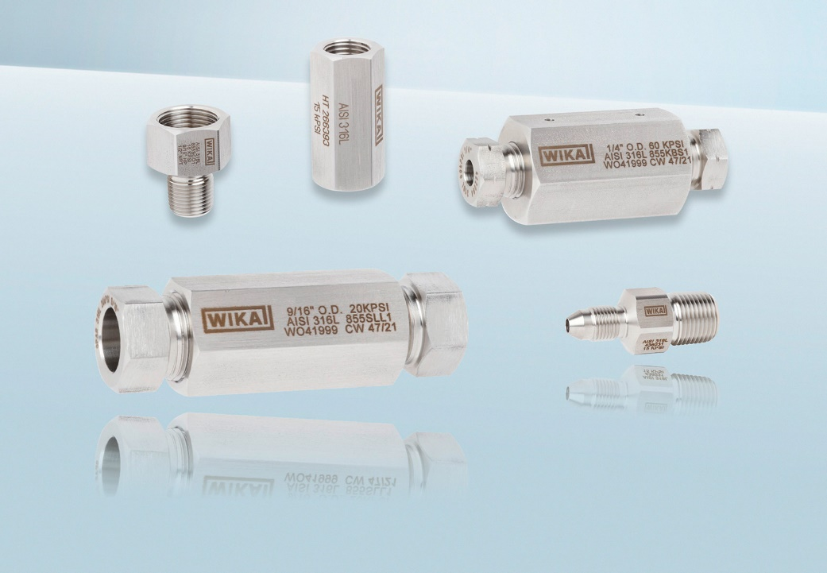
Model: HPAC

Edited by:
WIKA Alexander Wiegand SE & Co. KG
André Habel Nunes
Marketing Services
Alexander-Wiegand-Straße 30
63911 Klingenberg/Germany
Tel. +49 9372 132-8010
andre.habel-nunes@wika.com
www.wika.de

WIKA press release

