New industrial high-speed pressure controller

Klingenberg, May 2022. The model CPC3050 high-speed pressure controller is the newest device in Mensor's lineup of precision pressure controllers and can perform end-of-line three-point verification in ten seconds.

With an innovative regulator, the CPC3050 is designed for fast pressure control in industrial environments. It can perform 25 % pressure increments in under four seconds with a 0.020 % FS accuracy.

The CPC3050 maximises throughput in industries such as oil and gas and automotive manufacturing − however, it can be used whenever speed and accuracy are needed, for example: aerospace, aviation, pharma and power generation. It comes in high-pressure and low-pressure versions with customisable ranges, a 10:1 range limit ratio, and auto-ranging so it can fit into most factories for end-of-line testing and sensor verification.

Number of characters: 818
Code word: CPC3050

Manufacturer:
WIKA Alexander Wiegand SE & Co. KG
Alexander-Wiegand-Straße 30
63911 Klingenberg/Germany
Phone +49 9372 132-0
Fax +49 9372 132-406
Sales@wika.de
www.wika.de

WIKA company photograph:
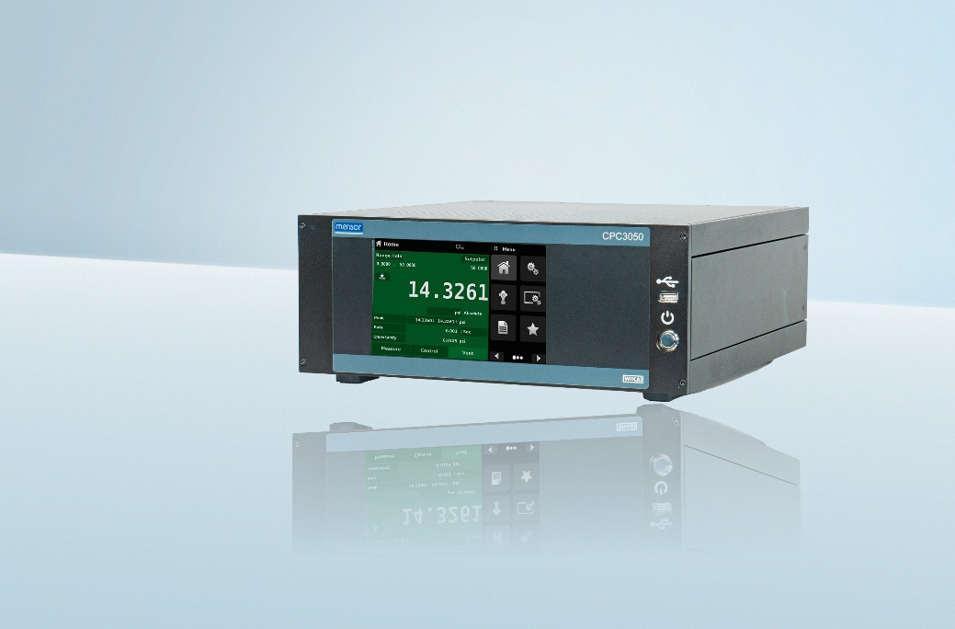
Model: CPC3050

Edited by:
WIKA Alexander Wiegand SE & Co. KG
André Habel Nunes
Marketing Services
Alexander-Wiegand-Straße 30
63911 Klingenberg/Germany
Phone +49 9372 132-8010
andre.habel-nunes@wika.com
www.wika.de

WIKA press release

