New tubeskin measurement

Klingenberg, April 2022. Inaccurate temperature measurements can cost the process industry significant time and money. Looking for a solution, WIKA engineers have designed a system that more accurately measures process furnace tubeskin temperature. Backed by rigorous testing at the WIKA R&D centre in Houston/US, the new TEFRACTO-PAD® (TC59-T) will allow users to meet production targets while protecting the furnace and maintaining tube integrity.

The TEFRACTO-PAD® model TC59-T addresses proven accuracy and ease of installation by taking into account the knowledge of customer applications, needs, and requirements. A proprietary moldable shield is placed over the thermo-pad and sheathed cable. This shield and insulation is a key component for the TEFRACTO-PAD®, providing accurate temperature monitoring.

The instrument is designed as two primary components (shield and pad) that have been combined to a single one-step installation process. With a major reduction in installation time and proven accuracy over a range of process conditions, this product is designed to be the engineered solution for your furnace application.

Number of characters: 1.106
Key word: TEFRACTO-PAD® (TC59-T)

Manufacturer:
WIKA Alexander Wiegand SE & Co. KG
Alexander-Wiegand-Straße 30
63911 Klingenberg/Germany
Phone +49 9372 132-0
Fax +49 9372 132-406
Sales@wika.de
www.wika.de

WIKA company photograph:
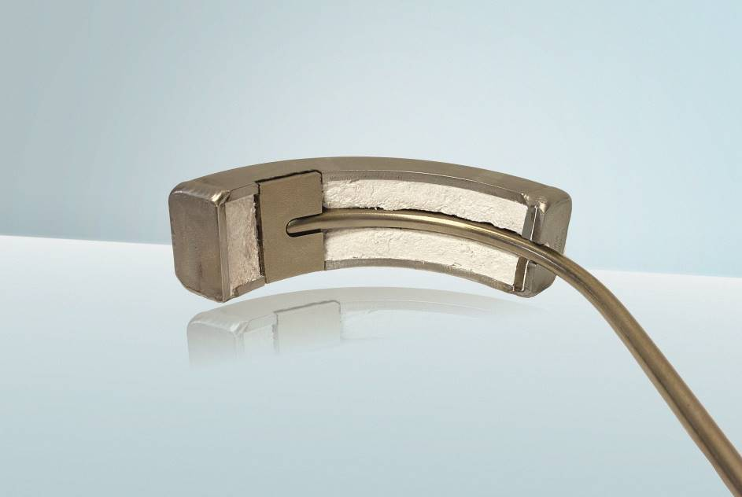
Model: TC59-T

Edited by:
WIKA Alexander Wiegand SE & Co. KG
André Habel Nunes
Marketing Services
Alexander-Wiegand-Straße 30
63911 Klingenberg/Germany
Phone +49 9372 132-8010
andre.habel-nunes@wika.com
www.wika.de

WIKA press release

